

**Haussmann Limited**

ACN: 617 865 960 ABN 3261 786 5960

**Table of Content** Project: HML Bromelton Plant

Plant infrastructure and external Infrastructure

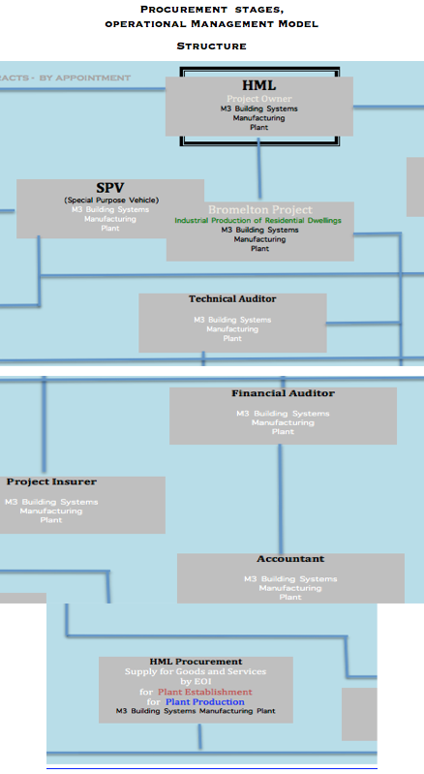

Management Options: Herein known as and referred to as: **MO**

Haussmann Limited**:** Herein known as and referred to as**: HML**

Special Purpose Vehicle: Herein known as and referred to as: **SPV 1**

HML Bromelton M3 Building Systems **Manufacturing Plant** Herein known as und referred to as: **M3 Plant**

Meinhardt Project Management**:** Herein known as and referred to as: **Meinhardt**

Projectus coordinating Engineers: Herein known as and referred to as: **Meinhardt**

Major Accounting Firm:Herein known as and referred to as: **Ashton**

**Operational Management Model Contract - designed by**: 1st. Contract Draft Agreement by MO - based on:

Draft by HML in consultation with **HML Contractors**

and summary result of meetings between MO

Team negotiator(s) and Haussmann Limited

**HML Contractors:** Contracted and or to be contracted Parties –

HML “ Project implementation -Team building” and their Roles:

1.) MO -  **Procurement** Consulting Team (to be appointed) Task 1: Procure: Stainless Steel Supply Agreement **Appointment:** Team Leader & Coordinator A.) Planning Team, B.) Implementation Team

2.) Meinhardt - **Project Management** (Group) (appointed) Task 1: Master plan for HML Bromelton Plant infrastructure **Appointment:** Team Leader & Coordinator A.) Planning Team, B.) Implementation Team

3.) Pro - **Coordinating Engineers** (to be appointed) Task 1: Identify 3 Plant Engineering Groups, capable to provide a blueprint for all engineered Plant production reference: HML Generic Plant design sections, identify suitable suppliers for machinery and Equipment - **Appointment:** Team Leader & Coordinator to join Procurement Team - A.) Planning Team, B.) Implementation Team

4.) Ashton - **Major Accounting** Firm (initial discussions with Ashton): – Project funding Submission: Qld. State Development, preparation Team (agreed in principal – (to be appointed). **Appointment**: Team Leader & Coordinator A.) Planning Team, B.) Implementation Team

**Demarcation Lines**: Between contractors and their teams - Line / boarder between the parties – appoint. Coordinator

**Demarcation Points:** Between contractors and their teams **-** hand over points – contact points between the parties - appoint. Coordinator

**Demarcation Transactions:** Between contractors and their teams – starting & ending database transactions- appointed Coordinator

**Bill of Quantities**: Procurement contracted entity, to prepare a bill of quantities, re variations types and sizes, if applicable to establish quantities and comparison in reference to establish purchase and contract and product advantages.

**Procurement Contract:**

Multi-pronged Management Procurement Services Contracting with Haussmann Limited

Reference: 2.3.1 Management Procurement Services Quotation No: MOPL2020.415

Procurement Contractor’s Planning, Management Administration division

reporting to Bromelton HML – SPV appointed Team Leader – end to end procurement functions.

**Procurement Programs:**

**The Project:** Haussmann M3 Building Systems Manufacturing Plant

A.) **Multi-pronged Procurement Programs and Hierarchy**

For: Planning, For: Establishment, For: Production

B.) **Individual Stages of each Procurement Program:**

Agreed outcome -results via documented discussion points

C.) **Staged -** and or **parallel -** and or **sequences** managed **Procurement Programs**:

Advise by Management Options

**A.) Procurement Programs**:

HML documented advise provided by MO

**Plant 1**: M3 Plant

**Procurements (Programs in 2 sections):** 1.) Plant Infrastructure Establishment

2.) Plant Production

**Procurement:** Dual Competency - Overall ability to negotiate.

Property (Land) purchase,

Goods & Services,

Machinery & Equipment, & Fabrication

**Via:** one off Tender, multi stage Tender, expressions of Interest

Strategic Partnerships,

Mergers & Acquisitions,

Management Contracts

**Location:** Bromelton State Development Area, Queensland, Australia.

## Bromelton State Development Area

We understand the proposed site for the Haussmann Ltd (HML M3) is to be located in the Bromelton State Development Area (SDA), which was declared in 2008. The SDA covers approximately 15,610 hectares and is located within the Scenic Rim Regional Council area, approximately 6 kilometres west of the Beaudesert township and 75 kilometres south of Brisbane.

We note that approximately 1,800 hectares of the Bromelton SDA is anticipated to be developed for industrial uses and has access to the national standard gauge rail network along the Sydney - Brisbane rail corridor, representing an ideal location for industries to access intrastate and interstate markets.

**Procurement:**

Acquisition/ Purchase :Land area $ 100 Acres

**Type of Land Area:**

1.) Green field Option, ( bare agricultural land area)

2.) Part -Approvals in place, (industrial zoning)

3.) Conditions to full approvals being part of the sale of Land area ( industrial zoning for HML Plant approved ).

**Land Zoning Choices**:

3 stages -Zoning choices :

Zoning approvals to be applied

Approvals partly granted

Zoning approvals granted

1.) Unimproved – greenfield – land area

2.) Partly approved – area

3.) Fully approved – area – Land holder(owner) agrees to seek and manage approvals, as part of purchase contract conditions stipulated by Haussmann Limited.

4.) Land Owners with a Strategic Interest: Plant 1 - (Bromelton SDA)

a.) Mervac

b.) Australian Rail Corporation

**Estimates - re Items and quantities**  to establish **Building 1 -** Preferred civil engineering contractor: Appointment via Procurement process.

consisting of Sections, A, B, C & D see attached PDF Report (106 pages).



**Procurement Programs for Plant:** Plant 1, (2, 3, 4 & 5) (Locations: Australia) Productions numbers per plant per annum: 70 000 homes– average size: 288 m2 homes, build by Haussmann teams Independent of electric. Grid. Fitted out with Kitchen and Bathrooms/showers/toilets, alum sliding doors and windows., including all in-builds. Decorative finished external and internal, hydraulic services for clean and waste water -– fire proof, vermin proof, cyclone proof. Solar system inlay film on roof area – Hydrogen Power storage. Underground rain water tanks – single unit sewerage treatment plant.

a.) Plant Number 1 – Bromelton Qld. Aust. b.) Plant Number 2 – Geelong, Vic. Aust. c.) Plant Number 3 - location to be decided d.) Plant Number 4 - location to be decided e.) Plant Number 5 – location to be decided

**M3 Plant Production (Building 1) output**: Type of Product produced: Productions numbers per plant per annum: 100 000 homes – average sizes: from 32 m2 to 48 m2 per home. Independent of electric. Grid. Fitted out with Kitchen and Bathroom/shower/toilet, alum sliding doors and windows. Decorative finished external and internal, hydraulic services for clean and waste water - inbuilt. – fire proof, vermin proof, cyclone proof – owner build.

1.) Single, Residential Dwellings: Affordable, sustainable, state of the art, precision and application engineered Housing. Market catchment area: Australia, New Zealand, New Guinea and the Pacific Islands.

2.) Emergency Housing, single Residential Dwellings : Affordable, state of the art, owner to build – HML designed –for on location to be build by the new owners. Leased to global AID Agencies at reduced HML profit margin being 8% only, to make the product truly affordable. Market catchment area: Global

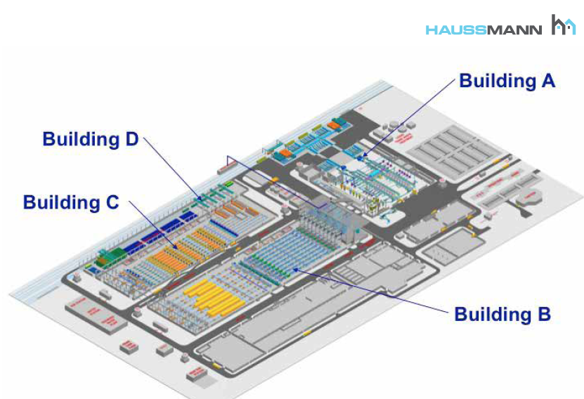

**M3 Plant Production (Building 2) output** Type of Products produced and or fabricated and or assembled **Estimates - re Items and quantities**  to establish **Building 2 -** consisting of: Main Building, Office Building, Water Treatment plant and Pond, underground Water retention holding areas - Car Parking - ingoing and outgoing Weight Bridges (2). Preferred civil engineering contractor: Appointment via Procurement process.

**Estimates - re Items & quantities** to establish, manufacturing. fabrication & storage facilities in **Building 2**

* **Aluminium Doors and Windows –** Extrusion, coating, assembly, storage.
* **Kitchen & In –builds & Bathrooms-** Manufacturing & assembly, storage.
* **Solid Surface Materials Production** – Manufacturing & storage.
* **Heavy Engineering –** Heavy engineered Items for Plant establishment, Transport Containers fabrication for sold Homes transport to client location.

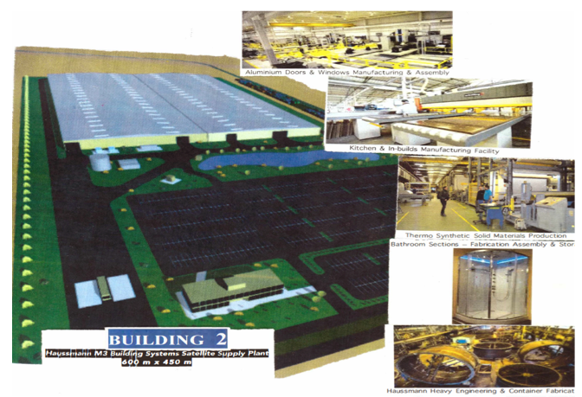

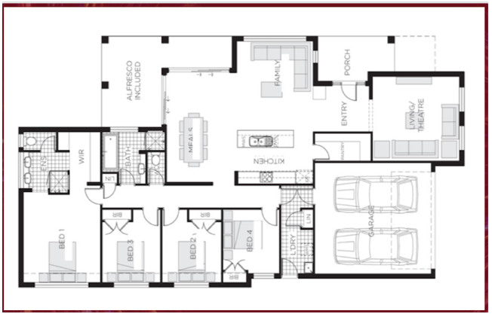

* **Aluminium Doors and Windows –** Cold, forward Extrusion – press – number of die cross sections –

die cross sections materials storage and assembly

* Coating sections – drying sections - assembly sections
* Aluminium Doors and Windows – Doors and Windows – assembly - glass joining aluminium section –
* Aluminium Doors and Windows – incoming goods storage - outgoing finished product goods storage
* **Kitchen & In –builds & Bathrooms-** Manufacturing & Assembly
* **Kitchens:** (3 Types to size and quality finishes)
* **In-Builds**: 2 Types to size and finishes
* **Bathrooms/Showers/Toilets/Laundry:** 3 Types to size and finishes
* **Roller Doors:** (3 Types to Size and finishes
* **Fixtures and Fittings** – general Hardware
* **Solar System** – (fitted during production in roof panels – inlayed as film. **Hydrogen** single dwelling power storage Units.
* **Single Sewerage Treatment Plant** – (2 Tanks)
* **Single Footings and square stainless Steel Grids** - Stainless Steel Tubes fabricated at Supplier’s facilities
* **Fitted – under foundation water tanks** to collect rain water

**Heavy Engineering:** 350 000 (flimsy) –Containers – Production pa. (non returnable) Containers to transport M3 Building systems and other Items to (build) dry assemble HML Homes to lock up stage on location.

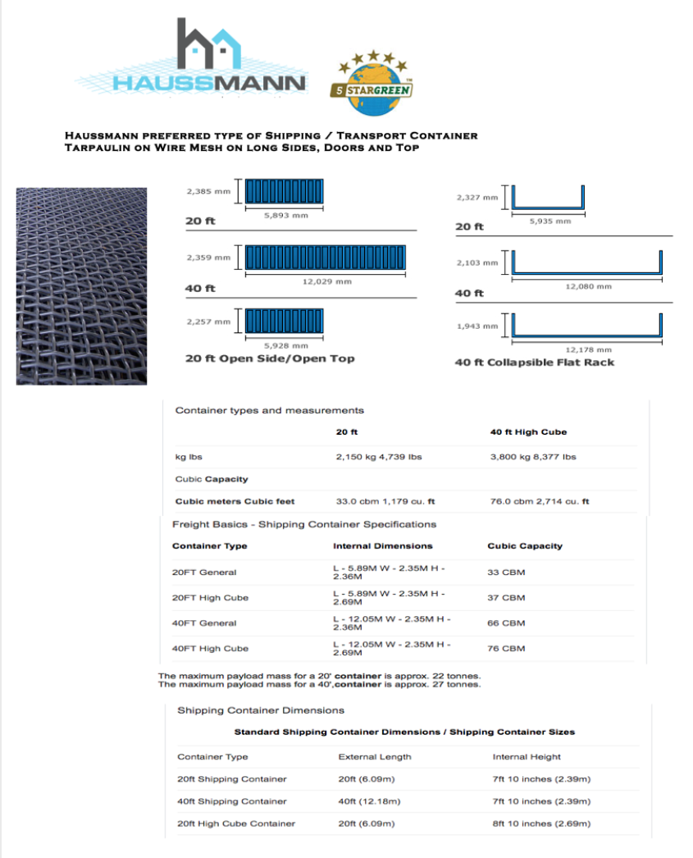

**Procurement Stages/Programs:** 3 Different Stages of Procurement;

1.) Planning

2.) Establishment

3.) Production

**Supply Chain Emissions factors** – Supply Chain Emissions - 75 different emissions factors – see publication:

Sustainable Procurement. “ Scotland eauc, the Alliance for Sustainability Leadership in Education. Internal Carbon Pricing Identify emissions factors for each nominated Supplier for Goods and Services etc.”.

Net Zero position Scale of emissions. CO2 – carbon credit offsets register for Haussmann Limited.

Haussmann Plant and product carbon credits. Carbon Pricing, the reality of Carbon Trading

Market values. Whole – life value and whole-life costing’s.

**Local, Regional, National and International** - sources of supply. HML structured list of suppliers sourced:

* in the first instance locally.
* HML sources of supply sourced from Germany
* HML sources of supply sourced Globally

**Waste Transfer Station :** Bromelton external location - HML Operation: Location Brisbane – Gold Coast Corridor - Yatala – preferred location – 110 000 m2 site size – from $ 5 m - $ 20 million –

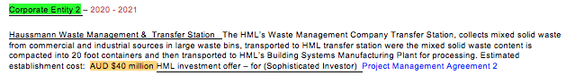

* ***Required Space/Areas***: Total 110 000 square meters, Truck parking area 16 000 square meters

Bin storage area 32 000 square meters, Container hard stand (empty Containers) 15 000 square meters

* Container hard stand (full Containers) 15 000 square meters
* ***Transfer Station*** (roof covered are): 16 000 square meters, product being unloaded from collection Bins (all sizes)

2 level operation- unloading waste from bins onto conveyor, conveyor feeding waste into compactor

Compactor pushing, compacting waste into containers.

* ***Site Office*** Building D.) ***Weigh Bridge*** E.) ***Container Hardstand (1 and 2)***

for outgoing (loaded) and empty containers (to be loaded).  F.) ***Land area*** required: Total 110 000 square meters

* G.) ***Type of Zoning*** required (and or to be obtained) if greenfield - cost per square meter from $ 50 to $ 200

Medium impact zone approval ready to build - $ $ 250 to $ 280 per square meter. (Road must be approved for V-Doub. Trucks).

* F.) ***Number of Container Movements*** per annum:

Movements of up to 120 - 150.000 - 20-foot containers are required to provide the plant’s feedstock of mixed solid waste per annum.

* Accordingly, a logistics/movement model of number of containers,***(empty container - hardstand)*** hardstand (***filled containers with waste - hardstand)*** is required.

Preferred civil engineering contractor: Appointment via Procurement process.

* **External infrastructure:** other then Building 1 and Building 2 -

**a.) Hydrogen – Gas fired Power Plant:**  Estimated establishment cost**:** AUD $ 180 – 200 million

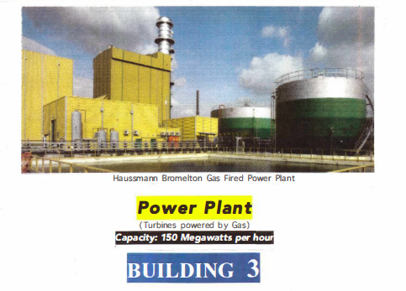

**Prefered Design and Engineering Contractor:** ThyssenKrupp – Australia – contact details and correspondence –

Preferred civil engineering contractor: Appointment by Procurement process.

* **Container Hardstands (2)** for Incoming and outgoing Containers:

Hardstand size for incoming Containers:

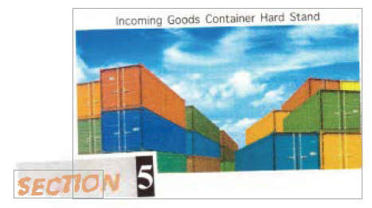

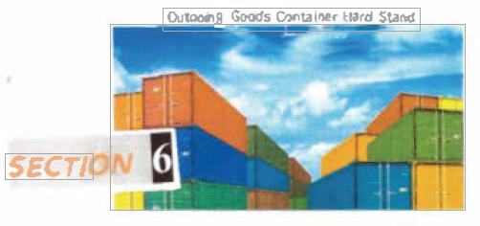

Hardstand size for outgoing Containers:

Preferred civil engineering contractor: Appointment by Procurement process.

* **Plant – internal Rail infrastructure** for Incoming Trains – for outgoing Trans – Shunting Lines and Rail Car interim storage – estimated cost: $ AUD $ 95 million

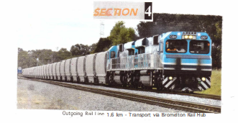

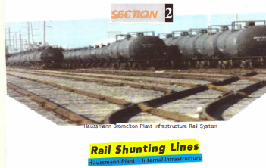

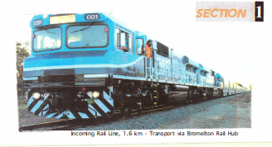

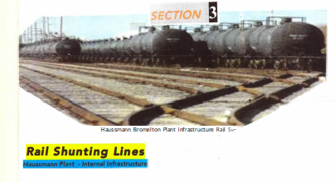

**Plant external infrastructure establishment** – Gas Pipeline Owner APA, Gas in Line – Owner APA

**Quoted cost for Pipeline** from Ipswich to Bromelton: AUD $ 27 million

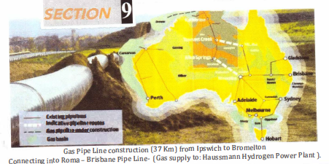

**Location not identified:**

**Cost not identified:**

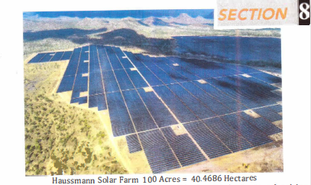

**Plant external infrastructure** establishment - ProcureLong term Port Facilities contract with Brisbane Port

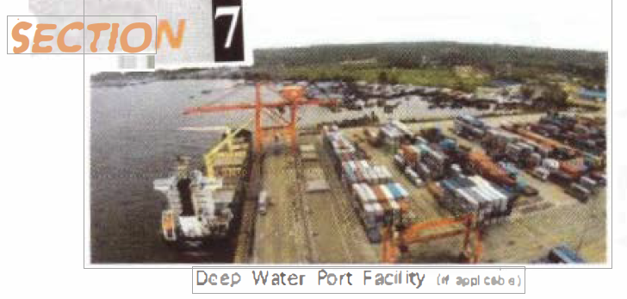

## Procurement for Production

* Cement - 60,000 tonnes per annum for a term of 23 years
* Binders - liquid / solid, total 950,000 tonnes per annum for a term of 23 years
* Polymers – 18,000 tonnes per annum for a term of 23 years
* Paints - coating panel systems - 23 million square metres per annum – 40,000 tonnes per annum for the term of 23 years
* Aluminium – 650,000 Doors and Windows, average size 4 x 4 metres - height 2.4 metres
* Stainless Steel Tubes - 8,320,000 linear meter lengths of extruded Aluminium
* Glass for Doors and Windows – 6,240 000 square metres per annum for the term of 23 years
* Stainless Steel Pipes for single Residential Dwellings foundations Steel Tubes – 80,000 tonnes per annum (738.6 linear metres per 288 square metre home) (13,776, 000 linear metres p.a.)
* Stainless Steel Tubes, flexible hoses and fittings, single Residential Dwelling - 104 linear metres - 0.10 cm diameter, plus fittings
* Hardware Fittings type and quantities
* Heavy Trucks 30 Waste Bins, not fitted with sling lifts and other fitted lift mechanism
* Waste Compactors - Hopers
* Waste Containers - 325,000 - 20 - foot Waste Containers for transport
* Annual production of 350,000 “flimsy” 20 - foot Containers to transport Home sections
* HML Homes - Lights and Light Fittings - Taps - Hardware Items
* Hot Water Heat Pumps – 70,000 per annum starting with 10,000 first 12 months followed ramp up to 70,0000 units
* Sewerage Treatment Plants - single Residential Dwelling Models - 40 – 70,000 per annum
* Solar / Hydrogen - Power Storage Systems, one per home – 70,000 Units per annum
* Air Conditioning Unit systems ducted servicing all rooms
* Electronic Entrance Door system – 70,000 p.a.
* Kitchens - 3 different sizes and 3 different quality finishes and equipment choices – 70,000 Kitchens per annum
* Kitchen built-in Oven, Microwave, Exhaust Ducting, Dishwasher, Sink Double Bowls, - 70,000 of each per annum
* Double Garage Doors – 70,000 per annum
* Bathrooms/showers/baths/toilets – 140,000 per annum
* Plant Production Maintenance supplies - machinery equipment to fit out and on-going parts supply
* Machinery and equipment for:
* Waste processing – B. Machinery and processing design List
* Extrusion processes to produce M3 Building Systems
* Extrusion processes to produce Aluminium shapes for Doors and Windows
* Drying processes
* Shaping and machining processes
* Coating processes
* Outgoing Products Packaging processes
* Robotics and materials handling stationed at different processes.
* Waste contracts with commercial and industrial waste source producer – mixed solid waste